Chapter 3 - Stoichiometry
Stoichiometry is the study of the relative amount of substance used in the chemical reaction. It comes from the Greek word Stoichion meaning element and the word Meteron meaning measure.
Importance of Stoichiometry:
It helps in the calculation of quantities of reactant and product by using the balanced chemical equation.
It is based on a balanced chemical equation that represents the mole-to-mole ratios of quantities.
3.1. Mole
When the Atomic mass of an atom, Formula mass of an ionic compound, Ionic mass of an ion and Molecular mass of a molecule expressed in grams, it is called moles.
For Example:
One mole of Oxygen= 16g (atom)
One mole of water H₂0 =18g (molecular mass)
One mole of NaCl=58.5g (Formula mass)
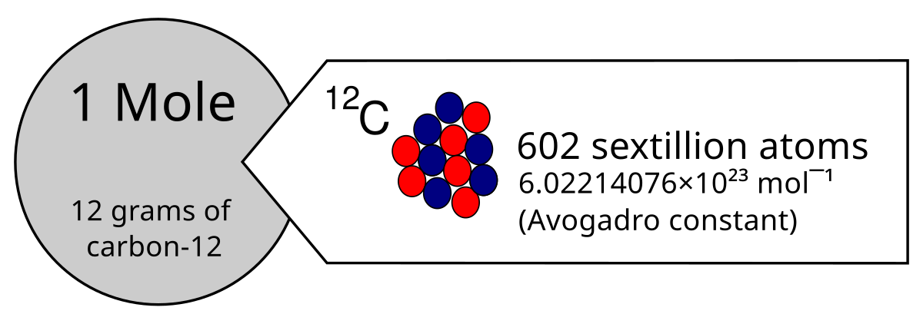
Mole Ratios in Stoichiometric Calculations
The Balanced Chemical equation will tell you about the ratio of reactant and product to the mole. The mole is the unit of measurement used to express the amount of substance. It symbolizes mol.
Molar Volume
One mole of any gas at RTP (Room temperature 25⁰C and pressure 1atm) occupies the volume of 24dm³ This is called molar volume.
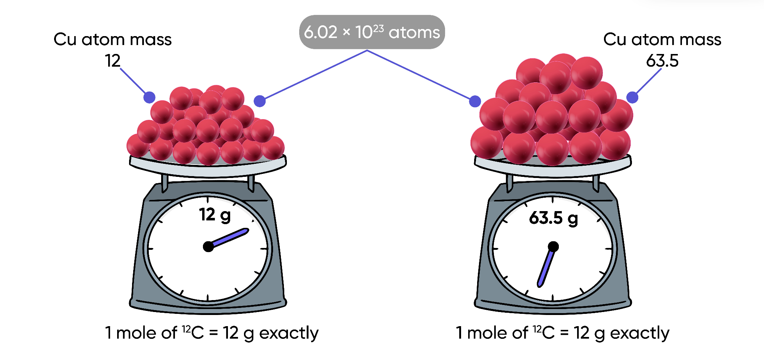
For Example:
One mole of H₂ = 2g = 24dm³ of volume
One mole of NH₃ = 17g = 24dm³ of volume
3.2. Percentage Composition
The relative amount of each element in a compound is called percentage composition.
Determine the Percentage Composition of a Compound:
· Calculate the molar mass of a compound.
· Calculate the percentage of each element in a compound.
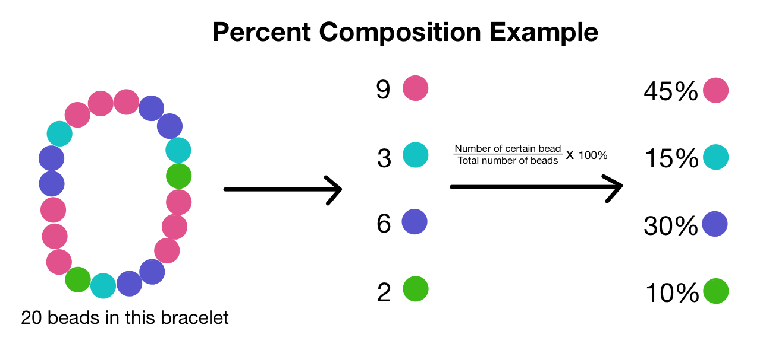
$\% of an element = \frac{mass of element in 1 mole of compound}{molar mass of compound}×100$
3.3. Limiting Reactant And Non Limiting Reactant
Limiting Reactant:
· The reactant that is completely consumed in reaction, is called limiting reactant.
· The reactant that produces the least amount of moles of product in the reaction, is called a limiting reactant.
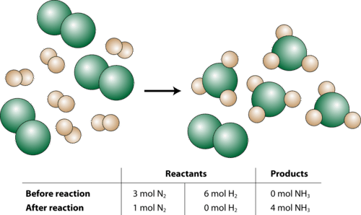
Non Limiting Reactant:
· The reactant that left unutilized or unreacted at the completion of reaction.
· The reactant which is in excess in the reaction, and produces a higher amount of moles of product relative to the other reactant, is called non limiting reaction.
3.3.1. How To Identify The Limiting Reactant In The Reaction
The limiting reactant can be recognized by calculating the number of moles of product by using the given amount of reactant in the balanced chemical equation.
The reactant that produces the least number of products is the limiting reactant.
3.4. Theoretical Yield, Actual Yield, and Percent Yield
Theoretical Yield:
The amount of product as calculated from a balanced chemical equation is called theoretical yield of the chemical equation.
Actual Yield:
The amount of product actually produced in the reaction is called actual yield.
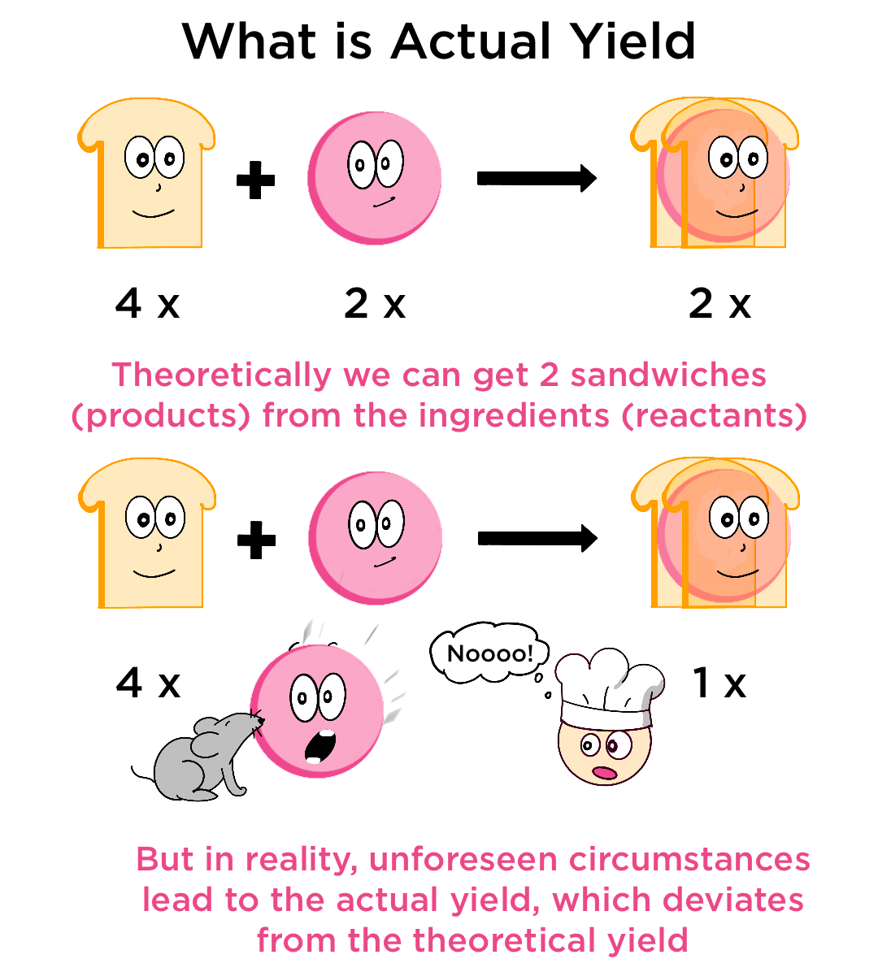
Percentage Yield:
The percentage yield is the measure of the efficiency of a chemical reaction, calculated as the ratio of the actual yield to the theoretical yield. It can be calculated as:
$Percentage Yield = \frac{Actual Yield}{Theoretical Yield}×100$
Why is the actual yield always less than the theoretical yield/ why is the percentage yield is less than 100%?
· Side reactions may occur that result in a By-product.
· Reaction may be reversible
· Mechanical loss may occur during filtration, distillation, separation by funnel etc.
3.5. Determining Empirical Formula And Molecular Formulae
Empirical formula:
The empirical formula of a compound tells you the simplest ratio of elements in the compound.
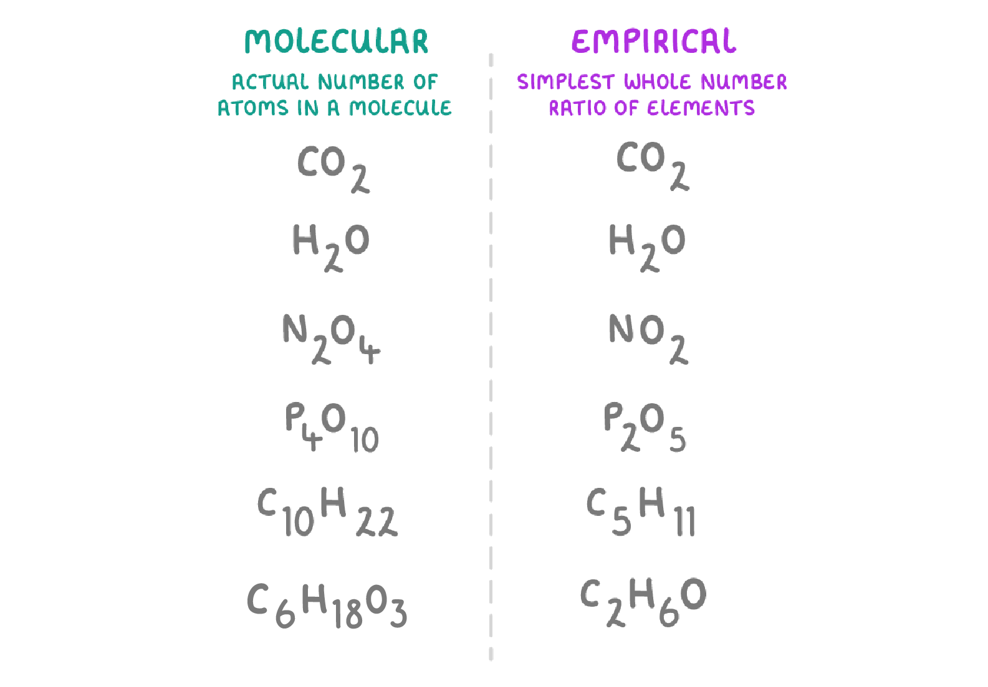
Molecular formula:
The molecular formula tells you the actual ratio of elements in the compound.
Determining The Empirical Formula Of A Compound:
· Find the number of moles of each element from its mass or percentage composition.
· Divide each element's molar amount by the smallest or least molar amount to get the simplest whole-number ratio of the compound.
· Write the empirical formula using the simplest ratio as subscripts.
Determining The Molecular Formula Of A Compound:
· Find the molar mass of the empirical formula.
· Divide the compound's molar mass by the empirical formula's molar mass. This will give you a whole number (n).
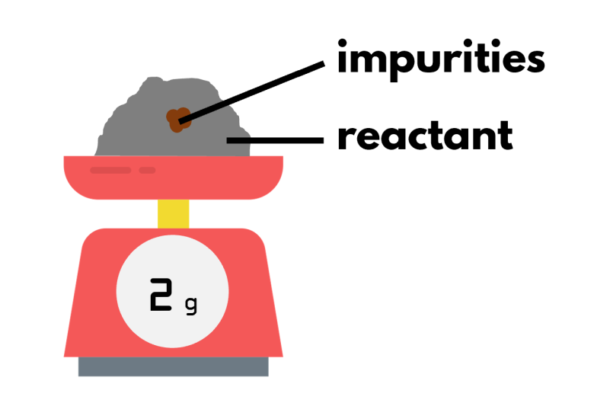
· Multiply all the subscripts in the empirical formula by n to get the molecular formula.
Percentage Purity
The amount of the pure substance in a sample represented as a percentage of the sample's total mass is known as percentage purity. You can determine the purity of a compound by comparing the amount of pure compound compared to the total mass of a sample.
The formula for percentage purity is:
$Percentage Purity=\frac{Actual mass of compound}{Total mass of sample}×100$
3.6. Concentration Units
Solution:
When solid solutes are dissolved in water, their molecules or ions readily move about in solution. They come in contact with one another readily in solution, so they combine easily, to form the solution.
Concentration Of Solution:
The quantity of a solute present in a given amount of solvent or solution is called the concentration of a solution.
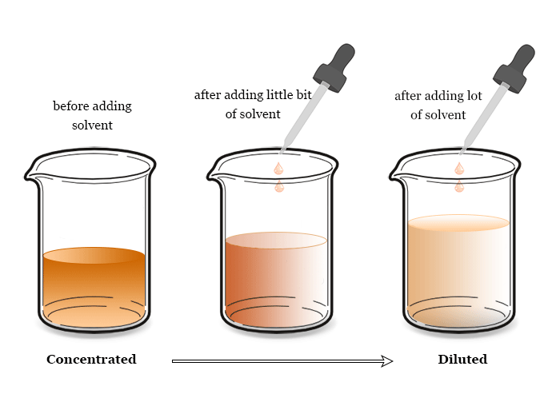
Dilute Solution:
A dilute solution is one where a relatively small amount of solute is dissolved in a larger amount of solvent.
Concentrated Solution:
A concentrated solution is a solution with a high concentration of solute relative to the amount of solvent.
3.6.1. Problems Involving the Molarity of a Solution
Molarity (M) (mol/dm³)
· Molarity is the concentration unit in which the amount of solute is expressed in moles and the quantity of solution in dm³.
· Molarity is defined as the number of moles of solute dissolved per dm³ of solution.
$M = \frac{Moles of Solute}{Volume of Solution}$
3.6.2. Problems Involving Interconversion of Molarity and Strength
Strength of a Solution
The strength of a solution refers to the concentration of solute in a given volume of solution. It is expressed in terms of grams of solute per unit volume of solution.
It is typically represented as:
· g/dm³ (grams per cubic decimeter)
· g/cm³ (grams per cubic centimeter).
These units express how much solute is dissolved in a specified volume of solution.
Strength of solution = Mass of solute (g) / Volume of solution (dm³ or cm³)
Mass of solute is measured in grams (g).
Volume of solution is measured in cubic decimeters (dm³) or cubic centimeters (cm³).
Unit Conversion:
1 dm³= 1000 cm³
So, to convert between g/dm3 and g/cm3:
1 g/dm³ = 0.001 g/cm³
3.6.3. Dilution of Solutions
Dilution is a process by which you make a solution less concentrated by adding more of the liquid (usually water).
Formula
$M_{1}×V_{1}=M_{2}×V_{2}$
M₁ is the concentration of the original (concentrated) solution.
V₁ is the volume of the original solution you use.
M₂ is the concentration you want after dilution.
V₂ is the total volume of the final solution.
Calculating The Concentration Of Solution By Titration:
· Fit up a clean burette in the burette stand vertically.
· Fill the burette with HCl solution up to zero mark.
· Take 10 cm3 of NaOH solution in a conical flask with the help of a pipette.
· Add a few drops of phenolphthalein as an indicator.
· Note the initial reading on the burette.
· Run the acid solution in the conical flask drop by drop, and shake the flask constantly.
· Go on adding the acid solution till the pink color just disappears.
· Note down the final reading from the burette.
· The difference between the final and initial readings gives the volume of the acid used to neutralize 10.0 cm3 of NaOH solution.
· Repeat the experiment to get three concordant readings.
· Find the mean volume of the HCl solution used.

